**PIZZA SALES SQL QUERIES**

select * from pizza_sales_excel_file

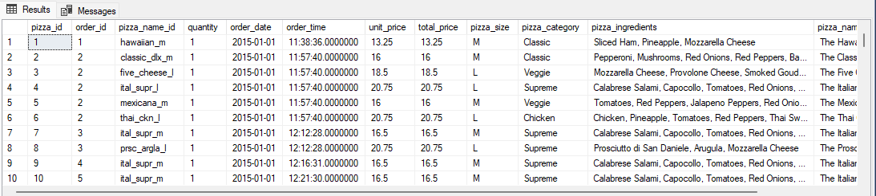

**A. KPI’s**

**1. Total Revenue**

select SUM(total_price) AS Total_Revenue from pizza_sales_excel_file

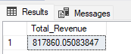

**2. Average Order Value**

select SUM(total_price) / COUNT(DISTINCT order_id) as Avg_Order_Value from pizza_sales_excel_file

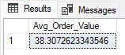

**3. Total Pizzas Sold**

select SUM(quantity) as Total_Pizza_Sold from pizza_sales_excel_file

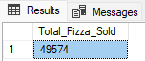

**4. Total Orders**

select COUNT(DISTINCT order_id) as Total_Orders from pizza_sales_excel_file

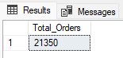

**5. Average Pizzas Per Order**

select CAST(CAST(SUM(quantity) as Decimal(10,2)) / CAST(COUNT(DISTINCT order_id) as Decimal(10,2)) as Decimal(10,2)) as Avg_Pizza_Per_Order from pizza_sales_excel_file

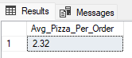

**B. Daily Trend for Total Orders**

select DATENAME (DW, order_date) as order_day, COUNT(DISTINCT order_id) as Total_Orders from pizza_sales_excel_file GROUP BY DATENAME(DW, order_date)

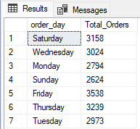

**C. Monthly Trend for Orders**

select DATENAME (MONTH, order_date) as month_name, COUNT(DISTINCT order_id) as Total_Orders from pizza_sales_excel_file GROUP BY DATENAME(MONTH, order_date) ORDER BY Total_Orders DESC

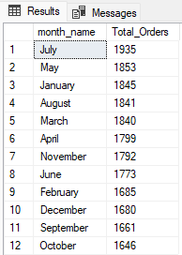

**D. % of Sales by Pizza Category**

select pizza_category, sum(total_price) as Total_Sales, sum(total_price) * 100 / (select sum(total_price) from pizza_sales_excel_file)as PCT from pizza_sales_excel_file GROUP BY pizza_category

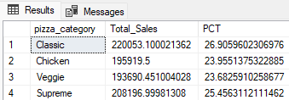

select pizza_category, sum(total_price) as Total_Sales, sum(total_price) * 100 / (select sum(total_price) from pizza_sales_excel_file WHERE MONTH(order_date)=1)as PCT from pizza_sales_excel_file WHERE MONTH(order_date)=1 GROUP BY pizza_category

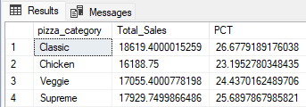

**E. % of Sales by Pizza Size**

select pizza_size, CAST(sum(total_price) as Decimal(10,2)) as Total_Sales, CAST(sum(total_price) * 100 / (select sum(total_price) from pizza_sales_excel_file)AS Decimal(10,2))as PCT from pizza_sales_excel_file GROUP BY pizza_size ORDER BY PCT DESC

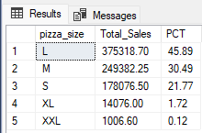

select pizza_size, CAST(sum(total_price) as Decimal(10,2)) as Total_Sales, CAST(sum(total_price) * 100 / (select sum(total_price) from pizza_sales_excel_file WHERE DATEPART(quarter, order_date)=1)AS Decimal(10,2))as PCT from pizza_sales_excel_file WHERE DATEPART(quarter, order_date)=1 GROUP BY pizza_size ORDER BY PCT DESC

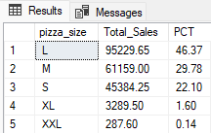

**F. Total Pizzas Sold by Pizza Category**

select pizza_category, SUM(quantity) as Total_Quantity_Sold

from pizza_sales_excel_file

WHERE MONTH(order_date) = 2

GROUP BY pizza_category

ORDER BY Total_Quantity_Sold DESC

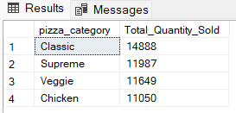

**G. Top 5 Pizzas by Revenue**

select top 5 pizza_name, sum(total_price) as Total_Revenue from pizza_sales_excel_file GROUP BY pizza_name ORDER BY Total_Revenue DESC

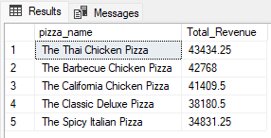

**H. Bottom 5 Pizzas by Revenue**

select top 5 pizza_name, sum(total_price) as Total_Revenue from pizza_sales_excel_file GROUP BY pizza_name ORDER BY Total_Revenue ASC

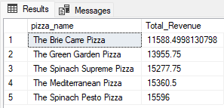

**I. Top 5 Pizzas by Quantity**

select top 5 pizza_name, sum(quantity) as Total_Quantity from pizza_sales_excel_file GROUP BY pizza_name ORDER BY Total_Quantity DESC

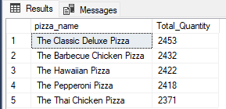

**J. Bottom 5 Pizzas by Quantity**

select top 5 pizza_name, sum(quantity) as Total_Quantity from pizza_sales_excel_file GROUP BY pizza_name ORDER BY Total_Quantity ASC

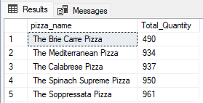

**K. Top 5 Pizzas by Total Orders**

select top 5 pizza_name, count(DISTINCT order_id) as Total_Orders from pizza_sales_excel_file GROUP BY pizza_name ORDER BY Total_Orders DESC

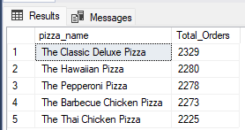

**L. Bottom 5 Pizzas by Total Orders**

select top 5 pizza_name, count(DISTINCT order_id) as Total_Orders from pizza_sales_excel_file GROUP BY pizza_name ORDER BY Total_Orders ASC

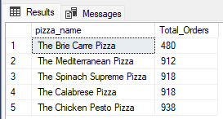

select top 5 pizza_name, sum(quantity) as Total_Pizzas_Sold from pizza_sales_excel_file WHERE MONTH(order_date)=8 GROUP BY pizza_name ORDER BY sum(quantity) DESC

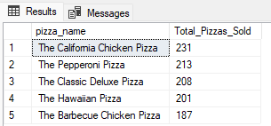

select top 5 pizza_name, sum(quantity) as Total_Pizzas_Sold from pizza_sales_excel_file WHERE MONTH(order_date)=8 GROUP BY pizza_name ORDER BY sum(quantity) ASC

